**TTT Bingo. Alpha version 1.0, unique session. Instructions and general rules.**

Author: Hugo W. Balcazar

This version of the game allows a minimum functionality in order to display

its current capabilities and its great potential. A new "Multi-Session" version

is currently under development, with a whole new set of features and bug fixes.

* This game is not meant to play alone.

* This game does not take decisions for the ADMIN.

* This game only supports one Admin per game session.

* This game does not hold a list of previous winners, players and cards.

* This game does not validate corporate data (emails, names, GPN codes, etc.).

(Only for this version)

* This game has no access to Outlook, Sharepoint services or any other

Microsoft 365 service.

* This game is not allowed for public in general. Only for a few specific persons.

(A “Multi-Session” version, currently under development, will allow any active employee

within EY.)

* This game has no support for mobile devices.

The list of features can be found in the Status Update file, attached to the

message on which these instructions were sent.

Target audience:

* Managers and technical staff.

IMPORTANT: Before entering the game, please send me your EY machine IP address in order

to give it permission to this game.

Game URL:

http://eyt3gameportal.azurewebsites.net

Let's begin...

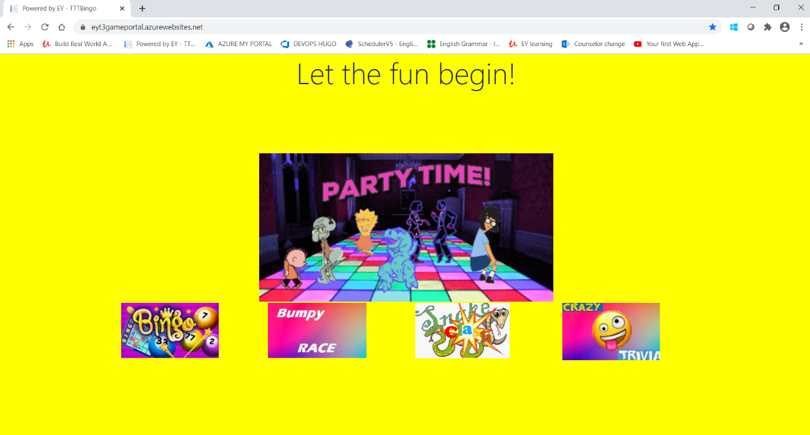

**General Rules**

1- This game has two important profiles for any user coming to play: ADMIN and Player.

2- The ADMIN can only perform administrative tasks regarding:

* Start the game.

* The mechanisms of the Bingo.

* The ADMIN doesn’t participate as player and has no rights to any prize.

* Chooses who wins or not, depending on his/her own criteria.

Although the game provides automatic tools for checking a player's card,

it will never take decisions for the ADMIN.

* Player's card check.

* Prize announcements.

* Winners registration.

* Contact the winners.

* The ADMIN will receive automatic messages in the following cases:

- There are no questions.

- There are more than one ADMIN (rejected automatically)

- There are less than 2 players in the current game. It will prompt

a panel with a summary of the winners and automatically end

the ADMIN's current session. Same for the last "lonely" player (without the

summary of winners).

* Maintain the tables clean and ready, before starting any new game.

(only for this version)

IMPORTANT: In order to play a "Classic Bingo", meaning, with numbers instead of

questions and answers, please make sure to enter them with the "_Number" format.

Example: "_1", "_2", "_3" and so on. Same for answers. This is because

I'm working on fixing this bug.

3- The Player:

* Enters the game through the Game URL provided above.

* Registers a Nickname or chooses an automatic player nickname, which will be

used during the whole life of this game.

* Receives an automatically generated Bingo Card with "answers" to the questions

that the ADMIN will randomly select for the player. These answers can be numbers or

"words". Depending on the type of Bingo being played (Trivia or Classic Bingo)

* All the players will see the moment a new question is being randomly selected

(on-screen wheel of fortune).

* All the players will see the same question on their screens.

* All the players will be able to mark hits on their cards.

* When a player wins a prize (LINE or BINGO), he/she will have to click on the corresponding

button (LINE or BINGO), before the on-screen Timer reaches the value of ZERO.

It is expected, however, it will not take more the 20 seconds for the player to hit the button

in such cases. The on-screen timer "Next question in N seconds" means that the game

is waiting for a response from the ADMIN, regarding other possible prize claims

he/she (ADMIN) may have been received, from another players.

* During this wait for the next question, the player may receive a message from the ADMIN,

informing the new Winners.

* If the Prize Type is LINE, the player can choose whether to continue or leave the game.

* For this version only, if the Prize is BINGO, however, the player cannot choose to continue

and the game ends here. Meaning, you can play as much LINE rounds as you want, until

the game runs out of questions or the number of players reaches less than 2 players.

* After the time for claiming a prize is out for this question, the button (LINE or BINGO) will

disappear and a message "Waiting for the next question" will show up.

* If the player wins a prize, it is expected that she/he will inform his/her real contact

information for a later contact.

* If it happens that only one player is left in the game, the game will automatically end the

current session for him/her.

**Game maintenance - ADMIN Guide**

WARNING: Make sure there is no previous data, before starting a new game.

IMPORTANT: ONLY the ADMIN of the Bingo will receive an email with the links below.

IMPORTANT: These "links" exist only for this Alpha version of the game. They won't be

available on future versions, since these functionalities will be included

in the ADMIN panel.

While I'm finishing the final options menu for the ADMIN, here is a list of important concepts

and tools for successfully administering a bingo game session. Good luck.

**Differences between "Start Over", "Reset game" and "Activate/Deactivate all questions"**

WARNING.

"Start Over":

URL:

http://eyt3gameportal.azurewebsites.net/Card/Index

This button allows to delete only the previous winners, cards, game events and

players. It also sets the status of all the existing questions to "Active" or

"Questions not asked". Thus, allowing new players and ADMIN to reutilize an

existing set of questions.

DANGER.

"Reset game":

URL:

http://eyt3gameportal.azurewebsites.net/Player/AddOrEdit

This button allows to delete all the previous data (winners, players, cards, questions)

and start a completely new game with a new set of questions.

WARNING.

"Activate/Deactivate all questions":

URL:

http://eyt3gameportal.azurewebsites.net/Question

In this page you'll find two buttons: "Activate all questions" and "Deactivate all

questions"

The main purpose of these buttons is two set the Status of all the questions to "Active" or "Inactive". This action doesn't affect the rest of the data in the current game.

An active question will be randomly selected and displayed by the Bingo system.

An inactive question won't be selected by the Bingo system. But it will be considered as one that was randomly selected and displayed during the course

of the game. The purpose of this functionality is to reuse the same set of

questions over and over if the players involved wish to continue playing for

hours.

**Check the current data before starting a new game**

Check for existing cards from a previous game:

URL:

http://eyt3gameportal.azurewebsites.net/Card

Check for existing players from a previous game:

URL:

http://eyt3gameportal.azurewebsites.net/Player

Check for existing winners from a previous game:

URL:

http://eyt3gameportal.azurewebsites.net/Winner

Check for existing game events from a previous game:

This data cannot be checked externally. It is an internal control

mechanism that the game implements to make possible the communication

between the players and the ADMIN. But it's correct to assume that if the Card link has

previous data, then there must be data for “Game Event” as well.

Check for existing questions from a previous game:

URL:

http://eyt3gameportal.azurewebsites.net/Question

**General Guide and Rules**

An example of a TTT Bingo game.

DANGER: Once the game has started DO NOT press F5 or refresh the page in any way. If any

player closes the browser then he/she won't be allowed to come back for the current game.

If you leave to go shopping or to wonder around and leave the session open, the game will

only "kick" you out if you are the last one in the current session.

1- A group of EY employees decides to play Bingo by using the recently released EY Gaming Platform.

2- They decide who will be the ADMIN of the Bingo. Having in mind, the ADMIN won't receive a card and will not have any prize.

3- Once they decide who will be the ADMIN, they must contact their immediate EY Counselor

requesting a new Bingo game session (only for this alpha version) and provide their personal

corporate data for registration (Full Name, GPN, Email, EY laptop IP Address).

They must indicate who will be the ADMIN.

The Counselor or selected contact will send a separate email to the selected ADMIN with the

links for administering the new Bingo session.

The Counselor or selected contact will give permission to the players for entering the game URL.

(only for this alpha version)

3- They enter the URL: http://eyt3gameportal.azurewebsites.net

Once inside, they select the option "Bingo".

4- The ADMIN will have the task of creating the new list of questions, adding one by one.

He must also check whether there are previous data and make a full clean if necessary.

I do not recommend using more the 15 questions for the sake of entertainment purpose.

More than that number will create a never ending and probably frustrating experience

for the players, since it will take forever to win a single LINE, let alone a BINGO.

5- Meanwhile, the players trying to enter the game will receive a friendly message

"Game is not ready. Please try again later."(only for this alpha version)

6- Once the questions are ready, the ADMIN will enter in the Bingo.

For that, he must register his "Nickname" as ADMIN (as indicated with capital letters).

It's very important that you agree with all the players that nobody can use this Nickname.

7- The game will welcome you (the ADMIN) with the preset game name "Welcome to TTT Bingo".

You'll see the number of players and a button "ON/OFF". DO NOT PRESS IT YET.

The Game will also show a couple of messages at the top of the screen:

"Game is OFF" and "Game Mode Not Set".

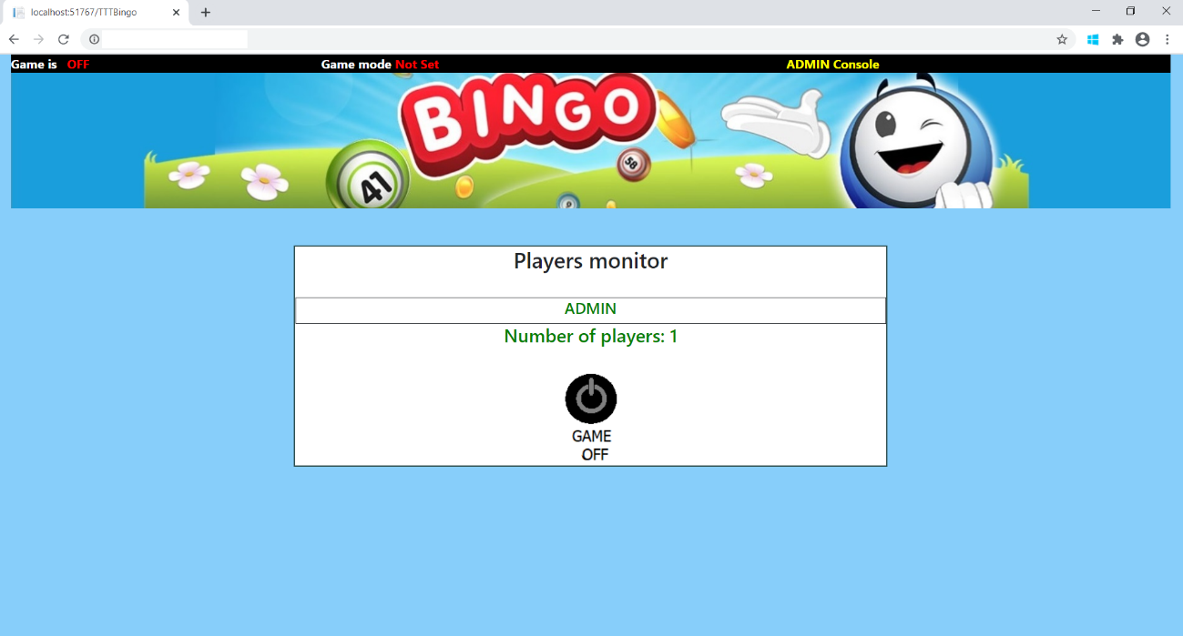

8- It is time for you (ADMIN) to inform the players that the game is ready to receive them.

9- Each player can register his preferred nickname or can opt to let the game to choose one

for him/her. The game, then, will create a new and unique random nickname like

"PlayerN638", where "Player" will be repeated for every random nickname, but the last

four letters will be completely random. No two players will be the same.

Then click OK. The game won't allow "Blank or NULL or White space" nicknames.

Although I didn't prevent the game to use special characters, it wouldn't make much sense, right? That will be fixed in future versions.

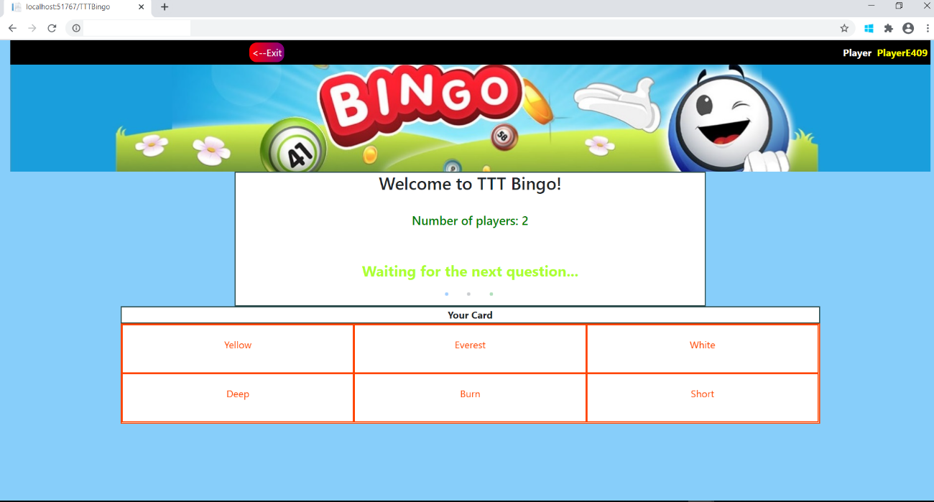

10- Once inside the game, the player will see his/her card with a set of six words, randomly

selected for this game. This card is unique for each player. Meaning, although they can

and will be repeated among all the players, the disposition and distribution on the cards

is different. There are no two equal cards. Each of these "words" are "answers" for the

corresponding set of questions that the ADMIN already loaded.

11- The Player will also see a message "Waiting for the next question" and a button "Exit" and

another message showing the number of players currently in the game.

12- The player can play around with the card, select and deselect "answers", although it is

recommended to leave them "unselected" until the questions begin to appear on the

Current Question panel. Such panel is not yet visible for the player.

13- Meanwhile, the ADMIN is watching the "Player's monitor". The number of players increases before his/her eyes and the last three players who have entered the game are

appearing on his "ADMIN console".

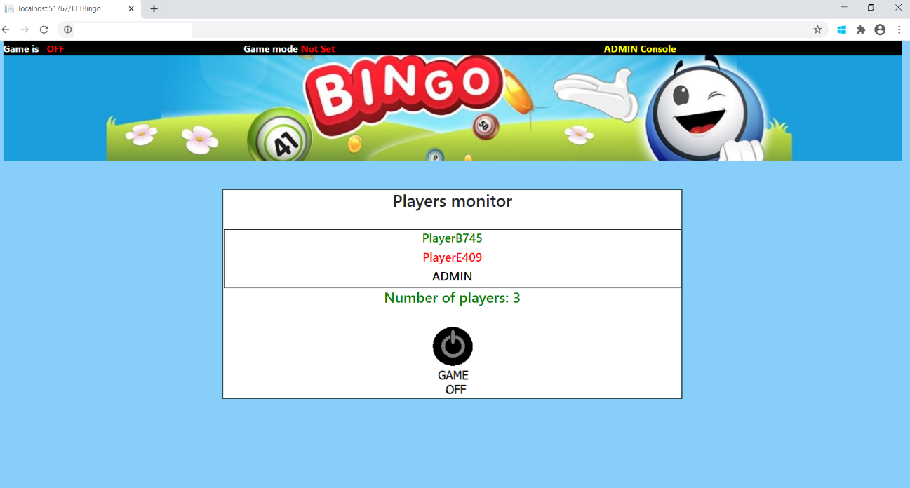

14- If the ADMIN determines there are some missing participants, he/she can urge them to join the game. The game has no time limits on waiting for players to join the game, BEFORE it has started.

15- Once the ADMIN determines the appropriate number of players has been reached, then the game can begin:

-> Click on "Start Game" to position "ON"

-> Select the Game Mode: LINE or BINGO.

You'll see how the "Game Mode Not Set" message at the top of the screen changes

to "Game Mode LINE" or "Game Mode BINGO", reacting to your selection.

IMPORTANT: Remember that the game will allow you all the LINE rounds you wish,

until runs out of questions or players. But the BINGO option (only for this version)

will allow ONE and ONLY ONE BINGO round. After that, the game will finish, no

matter how many active questions are still active. The only way to "Start over" will

be the one mentioned in the "Game maintenance - ADMIN Guide" section.

-> Click on "Play Now" button

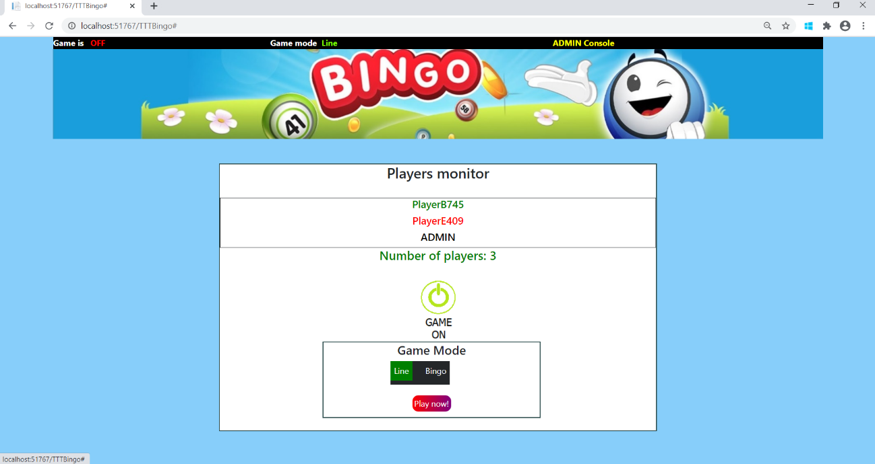

-> A button will appear on top of the screen "Confirm". Click on it.

-> In the time you used to officially "START" this game, new players could have

joined the game. Don't worry about it. Remember that only

"previously registered players" can join the game (only for this version).

-> You can be in constant communication with the players through MS Teams or

another EY chat but remember to focus on what you're doing. You are the ADMIN

of this game, the official immediate authority, so to say. The players rely on you.

-> You are now seeing a funny message "Click for the next question", "You can be the

winner". This is a reminder for you to animate your players to continue playing.

You can warn them before pressing this button if you want (“Are you ready?”).

Click on this funny yellow button, then.

-> You are now seeing a funny "Wheel of fortune" spinning in front of you, with a

message "Next question in 5 seconds". After that time, you'll see a new

panel "Current question" with a question in blue letters. The randomly selected one.

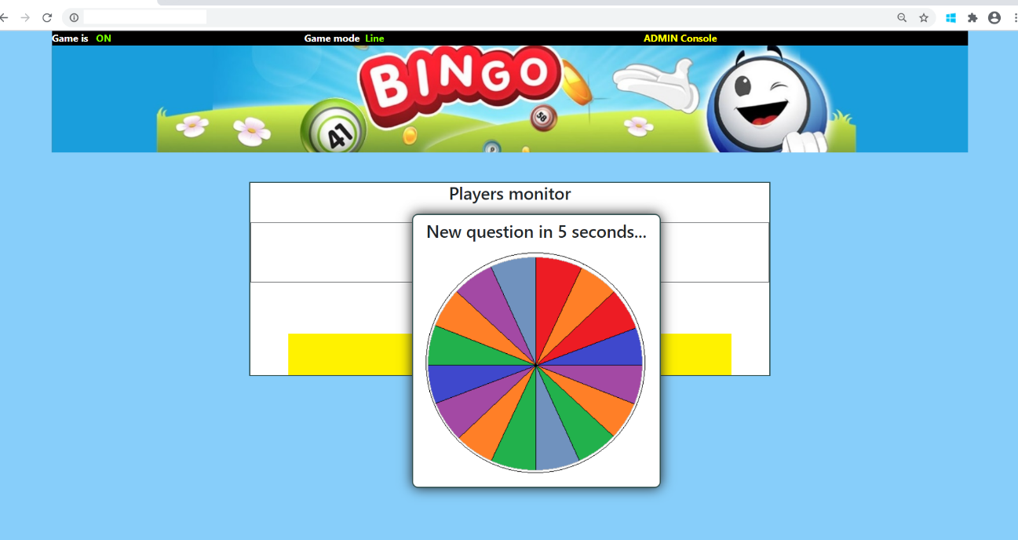

16- After those 5 seconds, your players will see the same "Wheel of fortune" and the

same question you are seeing on your screen.

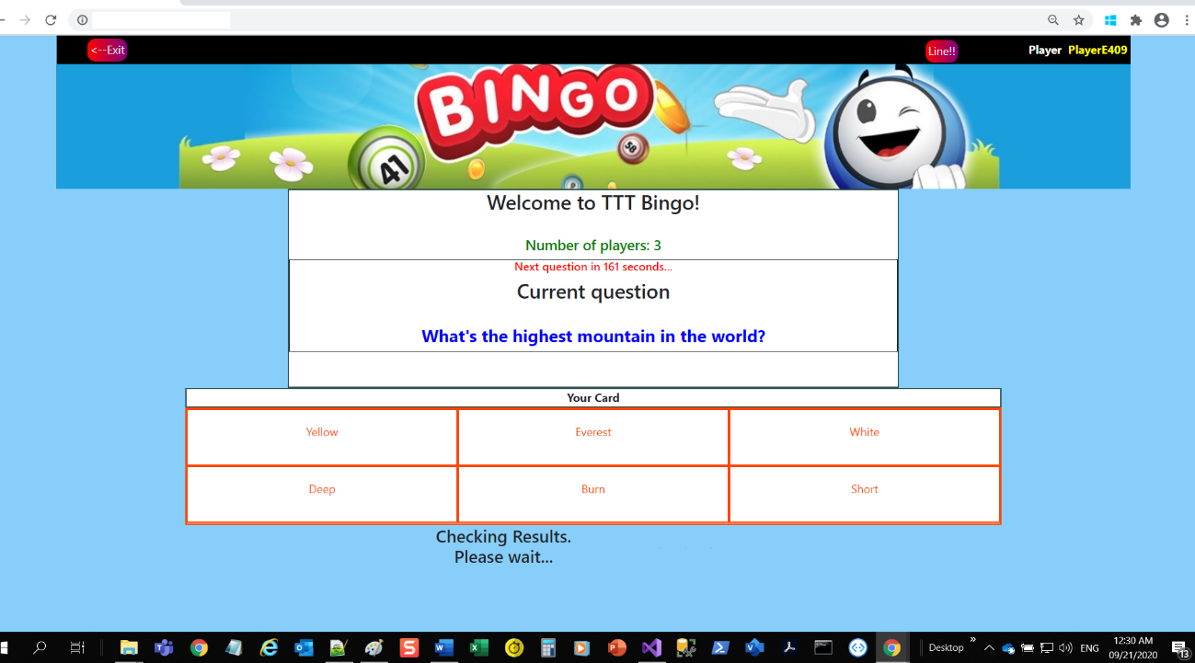

17- (ADMIN)Now your players will see a button at the top of their screens "LINE" or "BINGO"

depending on what Game Mode you selected when you started the game.

They will also see a countdown (Timer) telling them they have 240 seconds until the next

question shows up. But it shouldn't take more than 20 seconds for a player to mark

their hits on their cards, depending on whether they were lucky with the current question.

Once they click LINE/BINGO they will be automatically registered as "Potential Winners" and

will join a list of potential winners. A future version will display a countdown of 20 seconds

right next to the LINE/BINGO button. After which it will disappear.

18- At the same time your players are seeing the current question and thinking whether they

have a hit, a BINGO or a LINE, you (ADMIN) are seeing another countdown of about 40

seconds, on your screen. Saying "Waiting for winners”. After the 40 seconds, the game will

automatically retrieve the list of potential winners from the server and will display it to the

ADMIN. Since it wouldn't take more than 20 seconds for a player to mark his card or to

click on the LINE/BINGO button, the 240 seconds they see on their screens are actually

meant for you (ADMIN). It's the time you have to determine whether they (list of potential

winners) won or not, the Prizes they're claiming for. May be not all of them actually

marked the right answers. That is why you'll click on the links "Check" over each one of

them in order to determine who has the right to the prizes.

19- You (ADMIN) are now seeing a replica of the card that the player you selected has sent you

for revision. How to understand this card?

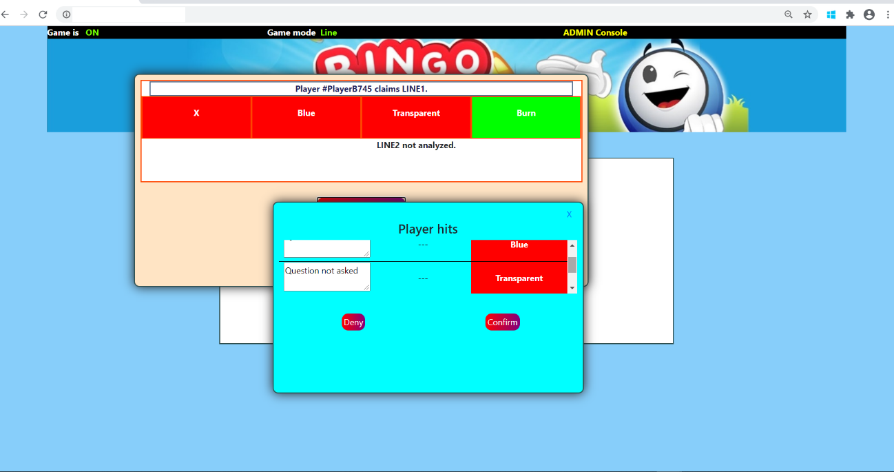

If this round is about LINE, you'll see that the card has one line with the message

"LINE 1/2 not analyzed". This means the player selected the other line as correct.

You'll also see the selected LINE, with all the answers marked with green color

or it may have some answers with red color. You can trust this automatic tool

or you can review them by clicking on "Show correct answers".

In this new panel, you'll see the question that belongs to every answer in the player's

Card (if correct) you are checking now or you'll see the message "Question not asked"(if not

correct). Meaning the answer, the player marked as correct on his/her card, hasn't been

made yet. Then again, you can check the URL

http://eyt3gameportal.azurewebsites.net/Question,

on a separate browser window to make sure which questions were made.

But you're running out of time. So, you can trust my automatic tool or

mark "Deny" the prize to the player and then deal with his/her claims

or mark it "Confirm" and risk being called by a Manager for "inappropriate"

behavior for giving a prize to a player who didn't have the right to it.

Now you see why I didn't make this part fully automatic and why this

type of Card Game needs an ADMINISTRATOR.

I cannot risk foul play and I (as developer of this game) must be transparent. In all cases this decision is up to you (ADMIN).

20- Now that you (ADMIN) are sure about your winners, you can "Notify Players".

Those who didn't win, will not appear in the panel of winners. That panel will be displayed

only for the players. The ADMIN won't see it, unless the current game is over.

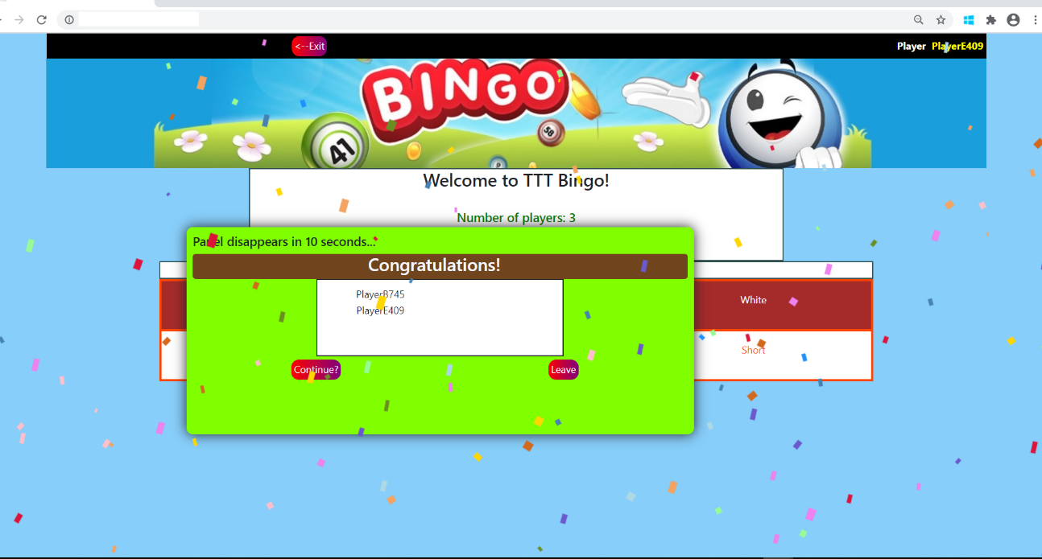

21- As I said it before, the game can end or continue depending on whether the players

want to continue or not.

22- Thank you for your time. Good luck, again. You can contact me through a Service Now ticket or by contacting my current (September 2020) Counselor, Douglas Borrero Villamizar.